About The Western Sunsetters

The Western Sunsetters became a group in 2004 and play a mixture of classic country, 50s/60s, and old tyme music. Original members include Brian Maetche (bass/guitar/harmony and lead vocals), Jim Cunningham (lap steel/slide guitar/harmony and lead vocals), Patti Bauer (guitar/bantar/bass/lead vocals), Trish Basile (piano/vocals), and Liz Anhorn (piano/accordion/guitar/harmony vocals). In 2006, Trish took a break from the group when she gave birth to her second child.
The Western Sunsetters began playing at Jamborees back in 2004 when they attended the Old Tyme Music and Dance Jamboree which was then held in Torrington. When that Jamboree moved to Olds, the group played both the 11th and 12th years there, as well as 2 years in Eckville at the 50s/60s Jamboree.
In 2007 the group ventured into Gospel music under the name All 4 Given, and just recently played for their second year at the Family Gospel Jubilee which is held the first weekend of May in Eckville.
The Western Sunsetters recorded their first CD titled “Our Classic Country Collection” in September 2007.
In July 2008, The Western Sunsetters will be playing at the 11th Annual Old Time Music Jamboree in Hanna and in November, will be at the Olds Legion.
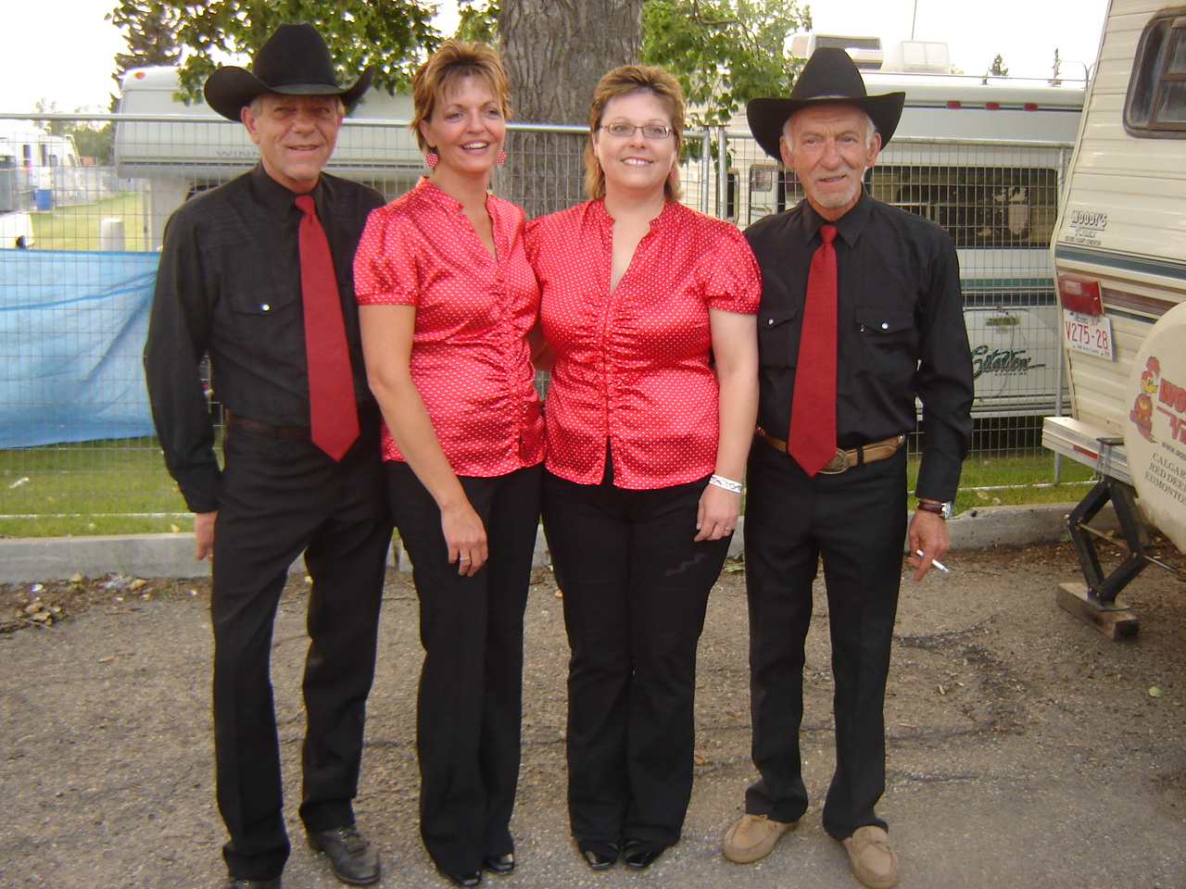

Left to Right: Brian Maetche, Patti Bauer, Liz Anhorn, Jim Cunningham

